Merit Planning and Promotion Entry for Executive Reviewers Quick Reference Guide
Last Updated: 3/15/2024

Purdue uses an online tool within SuccessFactors compensation module to manage the annual merit process. Executive Reviewer is a role within SuccessFactors. This role is part of the review process; however, it should not be confused with Senior Leadership. At Purdue, this role is generally assigned to Business Managers and DFAs.
It is the responsibility of Executive Reviewers to work with your assigned area to ensure that merit increase information is within budget, accurate, complete, and follows the annual merit guidelines.
This Quick Reference Guide (QRG) is intended to assist individuals assigned the role of Executive Reviewer. It outlines the Merit Planning Process, the audits that Executive Reviewers must complete, a tour of the Merit Planning Worksheet, and detailed information regarding the tools and reports that are available to Executive Reviewers to assist in the required audits.

Contents
Merit Planning Process Diagram 2
Required Audits 2
Access SuccessFactors 3
Pre-Merit Planning Reports 3
Merit Planning Employee Validation Report 3
Export Merit Worksheet 3
Access Executive Review Worksheet Overview 5
Select Population 6
Merit Planning Worksheet Tour 9
Top Menu Bar 9
Worksheet Column Highlights 10
Bottom Menu Bar 12
Entering Promotions (Faculty, Lecturer, Staff) 13
Reviewing Merit Data 15
Export Merit Worksheet 15
Post-Merit Planning Reports 17
Export Worksheet 17
Create Bell Curve Report 17
Export Detailed and Rollup Reports 17
Viewing Batch Processed Reports 20

Merit Planning Process Diagram
A

 | Required Audits
Executive Reviewers are responsible for the following audits. These may take place via Pre-Merit Planning Reports, Reviewing the Worksheet and/or any of the Post-Merit Planning Reports.
- Merit Increases
- Equity Increases
- Extra Merit
- Adherence to Budget
- Appropriate Comments for individuals with no merit increase or merit increase greater than 8%
- Faculty Promotion and merit increase alignment
- Concurrent appointments (check for matching merit increases)
- Benefits Premium Threshold (Merit Planning Employee Validation Report lists individuals approaching the current tier threshold mark that may require additional action or discussion if the threshold is crossed)
- Distribution of merit increase compared to performance (See Create Bell Curve/Quartile Report)
- Validate final rate of pay for AY staff and those with a less than 12-month appointment is within the equivalent pay band
- Ensure final annual salary for all lecturers is within the assigned lecturer pay band.

Access SuccessFactors
Via the OneCampus portal (one.purdue.edu), select Employee Launchpad.  Log in using Purdue Career Account ID and BoilerKey passphrase. |  | 

Pre-Merit Planning Reports
The section below outlines the reporting and exporting capabilities that can assist Executive Reviewers as they prepare for the Merit Planning process and during the process.

Merit Planning Employee Validation Report
Executive Reviewers should run the Merit Planning Employee Validation Report, found in the SuccessFactors Report Center, before or as soon as possible after the worksheets are launched.
It is recommended that Executive Reviewers set parameters for this report based on Compensation Manager, Division, or Department.
Some notes on fields found in the report that Executive Reviewers should review:
Position Entry Time | This field displays the hire date for the individual’s current position. If this field is blank or reflects 12/24/2019 or 1/1/1900, the individual was hired into their current position before the transition to SuccessFactors. If 1/1/2019 was listed, the individual was hired into their current position before the transition to SuccessFactors, OR they were hired on 1/1/2019.
Salary Band Analysis | Indicates if individual is Below, Within, Close to Over (within 3% below), or Over the Salary Range for the position. Caution: Lecturers and those with a 9, 10 or 11 month appointment may have inaccurate information.
Benefit Premium Review | Indicates if the individual is close to approaching the current Benefit Premium threshold. (Returns “Yes” if individual’s annual salary is within 3% of the threshold)
Concurrent Flag | This indicates that the individual holds multiple positions. Use this data to coordinate between departments to ensure aligned concurrent merit increase information.

Export Merit Worksheet
This process allows Executive Reviewers to export the data displayed in the worksheet.
The following columns can be edited and imported (by Executive Reviewers only):
- Merit Increase, Equity Increase, Extra Merit, Administrative Adjustment, Promotion, Comments
Note: Only Executive Reviewers are able to import worksheets. If you plan to export the worksheet, make changes, and import the changes, please review the Importing Merit Increase Data QRG prior to exporting the worksheet in order to understand all of the implications and cautions.
Click Executive Review  Use the Select Population instructions as needed so that the appropriate data is displayed.  Note: If you plan to export the worksheet, make edits, and import the worksheet, ONLY export the records for the individuals for whom you will be importing changes. |  | 
Click Export at the bottom of the worksheet |  | 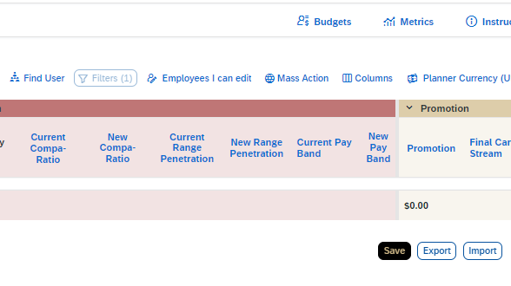
If you plan to make changes in the spreadsheet and import them, mark the checkbox at the top of the pop-up screen.  If this box is not checked, the file will not be importable.  At the point of import, all columns that were exported must be present, but the order of the columns is not of consequence.  Click Export |  | 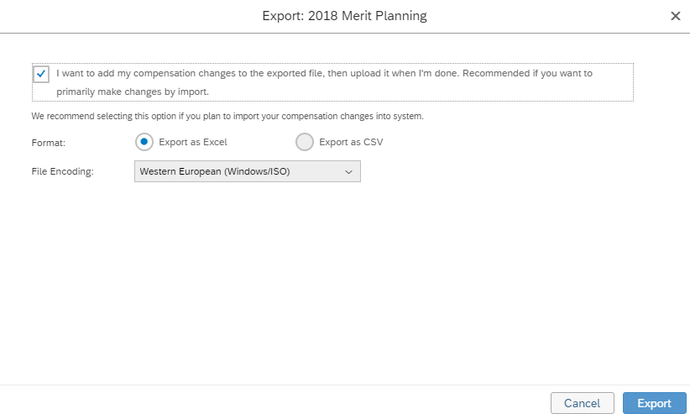
Open the exported file.  Save the worksheet on your computer in a location that you will remember. |  | 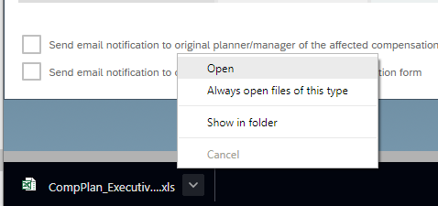
The exported file contains the same column headers as seen in SuccessFactors.  The columns that can be edited and imported are highlighted in yellow.  Notes:  - Changes to the yellow columns will not change non-highlighted columns but will update when imported. (e.g., if the Merit increase in dollars is increased, the Merit increase in percent will not change).  - Any columns or formulas added to the worksheet must be removed before import. |  | 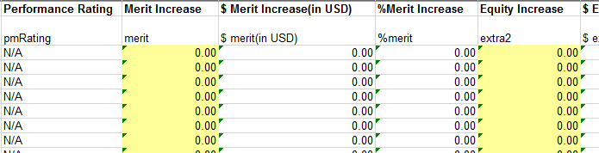

Access Executive Review Worksheet Overview
From the Home menu, select Compensation | 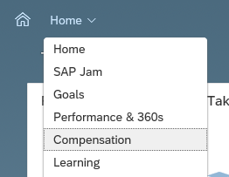
Click Executive Review | 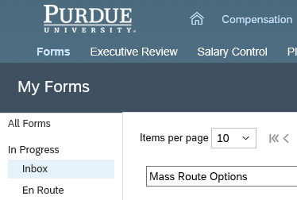
Choose the appropriate Merit Planning file | 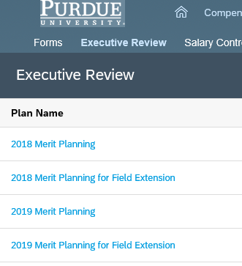
The merit planning worksheet is displayed.  Use the Population icon to manipulate the data displayed as desired (e.g., display only specific compensation manager hierarchy) | 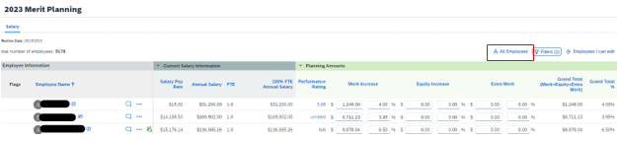

Select Population
Since the Compensation module is structured based on Compensation Manager hierarchy, it is important to choose a population based on this hierarchy. In order to create a Division-wide view, for example, Executive Reviewers should select a popluation based on the highest level Compensation Manager in the Division.
Use the Population icon to manipulate the data displayed. | 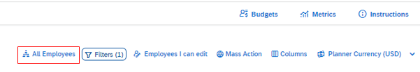
Population Overview:  Click on the population button - Name will reflect current population being viewed.  - “All Employees” pulls all employees across campus who are in a worksheet  - “Find User” allows for searching and selecting specific employees  - Can view multiple employees at once  - Can view multiple positions (concurrent) for an employee at once by selecting each position an employee holds  - Team View (First Manager)  - This is an administrative supervisor relationship as listed in the SuccessFactors org chart  - Direct Reports only – displays those who report directly to the selected user according to the SuccessFactors org chart  - Selecting multiple levels, displays administrative supervisor hierarchy as listed in the SuccessFactors org chart  - Team View (Second Manager) is synonymous with Compensation Managers in SuccessFactors. Team View with direct reports only selected displays employees for whom the selected user is the assigned compensation manager. Multiple levels selected displays those in the selected user’s compensation manager hierarchy for each level selected.  - Matrix Reports – Displays anyone for whom the selected user is a matrix manager  - HR Reports and Custom Manager are not applicable currently  Note: Checking the “Include Inactive Users” box will pull in anyone who has separated from the university since the worksheets were created. Leaving this unchecked will leave separated employees out of the worksheets. | 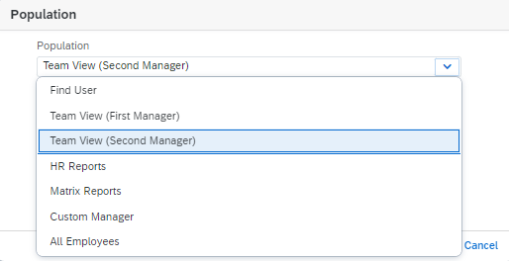  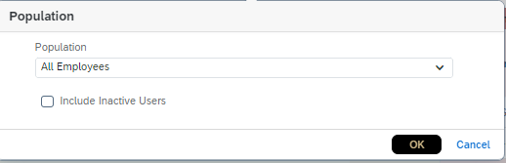  1  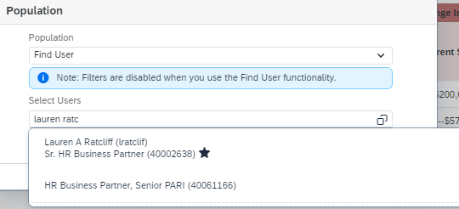  2  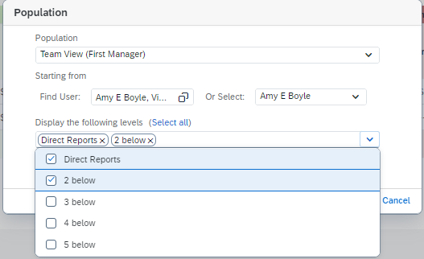  3  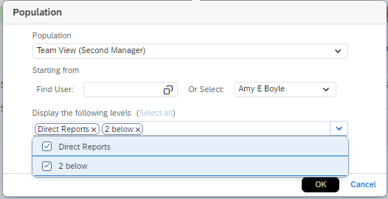  4  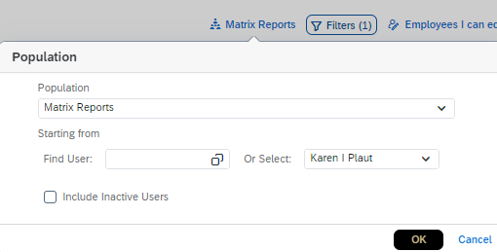  5  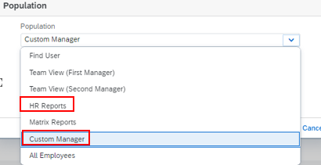  6
To display by compensation manager, choose population Team View (Second Manager) as directed above.  - Use the Find User field to locate the Compensation Manager  - Select radio dial next to Compensation Manager’s name and click on Select  - Choose the population to display. Select all displays the entire hierarchy under this Compensation Manager. Selecting Direct Reports only pulls in only those for whom this person is a Compensation Manager. Choose the levels to pull in and click OK. Note: There may be several levels under a selected user as this is based on the overall compensation manager hierarchy. Including inactive users will pull in those who have separated since the merit worksheets were created. Unselecting ”Include Inactive Users” will remove those who have separated since the worksheets were created. | 1  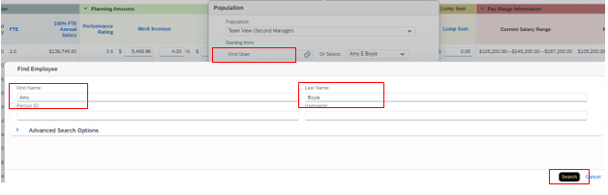  2  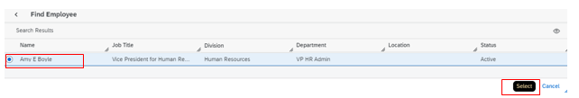  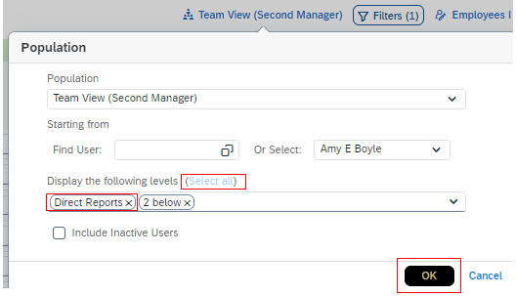  3
Once population is selected, employees are displayed | 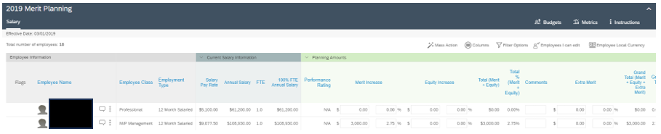

Merit Planning Worksheet Tour

Top Menu Bar
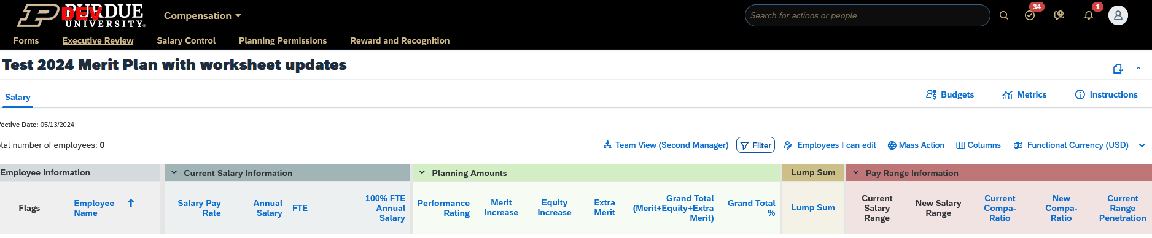
6
5
4
2
3
1
1 | The Budgets widget displays Budget Total allocated to you, the Total already allocated through your work on the sheet, and the amount Remaining. Budget Total aligns with salary control. Total only includes what’s been allocated to active employees (even if inactives are pulled in).  The Budgets widget can be clicked, dragged, and placed anywhere on the screen so that it is aways visible.
2 | The Metrics widget displays the following data for the individuals on the worksheet: Performance Distribution, Pay/Performance Matrix, and Merit Increase to Performance Rating. Compensation Managers should consult this widget to ensure a consistent application of merit increases compared to performance rating.
3 | The Instructions tab links users to the location of references and information that can assist in completing the worksheet.
4 | The Columns icon allows the user to hide or show columns on the worksheet
5 | The Population icon allows the user to choose the appropriate compensation manager hierarchy in the worksheet. It also allows for selecting specific employees and concurrent positions.
6 | To Sort, click any column label in blue lettering.

Worksheet Column Highlights
The worksheet contains many columns divided into sections. Some columns are informational, and some are used to enter merit increase data. This section outlines the columns requiring additional explanation.
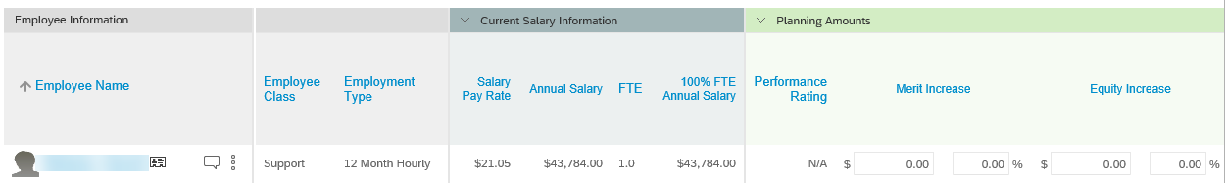
Section |  | Column Name | Notes (if applicable)
Employee Information |  | Employee Name | To view additional information related to the employee, click the Business Card icon next to their name, or see the Additional Information columns on the far-right end of the worksheet.
Current Salary Information |  | Salary Pay Rate | Displays the pay rate per pay period (may be hourly or monthly)
 |  | 100% FTE Annual Salary | When reviewing Current Salary Information, it is important to consider individuals with FTEs less than 1.0 and individuals with Academic Year appointments or any appointment less than 12 months.
 |  | FTE
 |  | Annual Salary
Planning Amounts |  | Performance Rating | Click the rating to view the individual’s performance documentation.  The performance rating is imported from the Performance module.
 |  | Merit Increase ($ and %) | Use these fields to input a merit increase amount for each individual. Enter in the $ or % column, the other column will auto-populate.  This field draws from the budget.  Comment Required in Comment field If:  - NO merit increase  - Examples: “Hire Date Restriction”, “Performance”, “Resigned”, “Retiring”  - Merit increase of greater than 8%  - Examples: “Performance” or “Equity”
 |  | Equity Increase ($ and %) | This field is rarely used. If you believe you have reason to use this field, please consult with your area’s Compensation Specialist.  This field draws from the budget.
 |  | Comments | Comments are visible to all reviewers. Take care to avoid sensitive or personal comments, and comments that violate HR policy.  Comment fields are limited to 500 characters.  Comment Required in Comment field If:  - NO merit increase  - Examples: “Hire Date Restriction”, “Performance”, “Resigned”, “Retiring”  - Merit increase of greater than 8%  - Examples: “Performance” or “Equity”  - Admin Supplement  - Current supplement adjusted or zeroed out (must still work with payroll to remove wage type from employee  - New adjustment added
 |  | Extra Merit ($ and %) | Extra merit is typically entered by the Executive Reviewer.  If applicable, use these fields to input extra merit. Enter in the $ or % column, the other column will auto-populate.  This field draws from the budget.
Lump Sum |  | Lump Sum | This field draws from the budget and is used when an employee’s annual salary is above the maximum of the assigned pay band or when their merit increase will push the employee’s annual salary above the maximum of the pay band.
Current Admin Adjustment |  | Administrative Adjustment Date | The date that the current Admin Adjustment began.
Planning Admin Adjustment |  | Annual Admin Adjustment Amount ($ and %) | Use these columns to add, carry forward or change administrative adjustments. The fields will be gray for individuals not eligible for Admin Adjustments.  Enter in the $ or % column, the other column will auto-populate.  - Entries in these columns will overwrite the Current Admin Adjustment columns.  - Admin Adjustments cannot be removed as a part of this process. (Entering zero will remove payment from the employee but not remove the wage type from their profile. Follow normal procedures to remove this.)  This field does not draw from the budget.
 |  | Comments | Comments are visible to all reviewers. Take care to avoid sensitive or personal comments, and comments that violate HR policy.  Comment fields are limited to 500 characters.  Comment Required in Comment field If:  - NO merit increase  - Examples: “Hire Date Restriction”, “Performance”, “Resigned”, “Retiring”  - Merit increase of greater than 8%  - Examples: “Performance” or “Equity”  - Admin Supplement  - Current supplement adjusted or zeroed out (must still work with payroll to remove wage type from employee  - New adjustment added
New Salary Information |  | Promotion ($ and %) | Reflects any promotions entered.  This field does not draw from the budget.
 |  | Total Annual Increase | Reflects all increase (Merit, Equity, Extra Merit)
 |  | Final 100% FTE Annual Salary | Reflects new final annual salary at 1.0 FTE.  Data for individuals with a less than 12-month appointment may appear skewed.
Pay Range Information |  | Salary Range | Salary Ranges are determined based on market value for the position. Sources of market data vary by position.  - Salary Range data for Executives, Faculty, and Researchers is very broad and should not be used for planning purposes.  - Salary Range data for individuals with less than a full-time fiscal year appointment may appear skewed.
 |  | Current Compa-ratio | The comparison of the individual’s full time equivalent salary to the market rate for the position. (Examples: 100% Compa-ratio indicates that the individual’s salary is at the market rate. 75% indicates that the salary is 25% below market rate. 125% indicates that the salary is 25% above market rate.)  - Compa-ratio data for Executives, Faculty, and Researchers is based on Salary Range and therefore is very broad and should not be used for planning purposes.  - Compa-ratio data for individuals with a less than full time fiscal year appointment may appear skewed.
 |  | New Compa-ratio | Reflects Compa-ratio after data from worksheet is applied.
 |  | Current Range Penetration | The position of the employee’s pay within the pay band. (Examples: A range penetration of 50% means the individual’s salary is at the median or market rate. A range penetration over 100% means that the individual’s salary is above the maximum of the pay band.)
 |  | New Range Penetration | Reflects Range Penetration after data from worksheet is applied.
 |  | Publish Date | Effective date of the merit increase.
Additional Information |  | Emp User ID | Personnel Number (PERNR)
 |  | Job Title | Internal Job Title Classification
 |  | Service Date | Original Purdue Hire Date. This is not the hire date for the individual’s current position. The Service Date may be adjusted if an individual has left and returned.

Bottom Menu Bar
2
1
4
3
5
6
1 | Items per page allows the user to change the number of rows displayed. This can be helpful if the user wishes to view all lines on one page and avoid navigating between pages.
2 | The Page arrows allows users to navigate between any additional pages of the worksheet.
3 | The Import button allows Executive Reviewers to import a previously exported file on which changes have been made.
4 | The Export button allows Executive Reviewers to export the data currently displayed on the sheet (including subsequent pages).
5 | Clicking Cancel clears all unsaved data entered in the worksheet.
6 | Use the Save button often to avoid losing data. Ensure that the Save operation is complete before moving forward. Always save before navigating to a new page. SAVE OFTEN.

Entering Promotions (Faculty, Lecturer, Staff)
Follow the instructions to Access Executive Review Worksheet Overview and Select Population by Compensation Manager as appropriate).
Hover over the vertical ellipsis to the right of the employee being promoted.  Click on Promote  Caution: Do not enter promotions moving an employee from the Administrative & Operational Support and Police, Fire & Skilled Trade (S, SK) career streams to the Professional (P) or Management (M) career streams. (Hourly to salary)  Compensation will ensure this type of promotion is entered. | 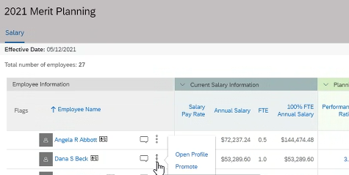
Enter new job classification (2000XXXX). (Pay grade, Job Title and Career Stream will automatically update once new job classification is entered).  Update position title.  Click Show 15 more Fields.  Ensure information only in the circled fields changes.  Click Save. | 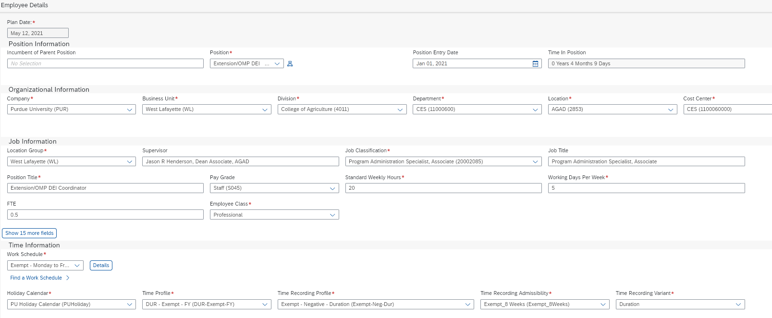  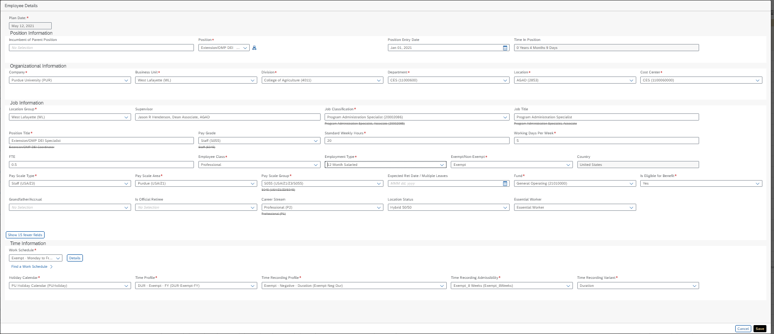
Promotion is indicated by green silhouette next to the vertical ellipsis. | 
Enter promotion increase. | 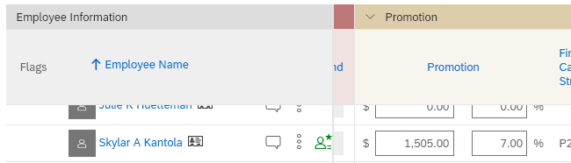
Verify promotion section of worksheet accurately reflects final career stream, position title, job code and job title. | 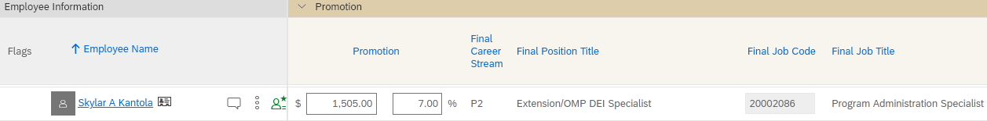

Reviewing Merit Data
Follow the instructions to Access Executive Review Worksheet Overview and Select Population by Compensation Manager as appropriate.
Open the Budget widget.  Add Extra Merit if appropriate / allowable by area practice. | 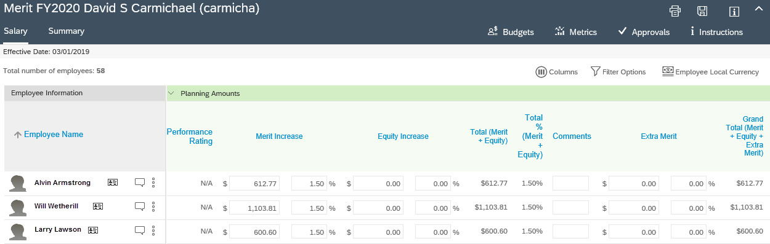
Review/edit any other data as desired, ensuring compliance with budget/salary policy.
Ensure that all Required Audits are complete, either within the worksheet or via Pre-Merit Planning Reports or Post-Merit Planning Reports.
Before making any changes in the worksheet, coordinate with the Compensation Manager and/or the One-Up Compensation Manager.  As appropriate, mark the checkboxes to send notifications that data has been changed.  - The email notification will state that data has been changed and by whom.  - The notification will not list the individuals whose data has been changed.  Click Save. | 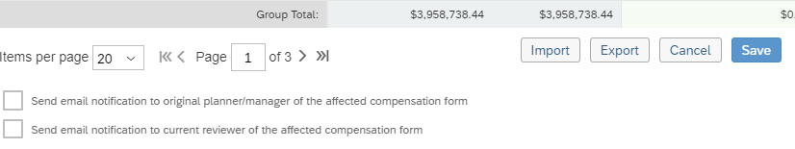

Export Merit Worksheet
This process allows Executive Reviewers to export the data displayed in the worksheet.
The following columns can be edited and imported (by Executive Reviewers only):
- Merit Increase, Equity Increase, Extra Merit, Administrative Adjustment, Promotion, Comments
Note: Only Executive Reviewers are able to import worksheets. If you plan to export the worksheet, make changes, and import the changes, please review the Importing Merit Increase Data QRG prior to exporting the worksheet in order to understand all of the implications and cautions.
Click Executive Review

Use the previous Select Population instructions as needed so that the appropriate data is displayed.

Click Export at the bottom of the worksheet | 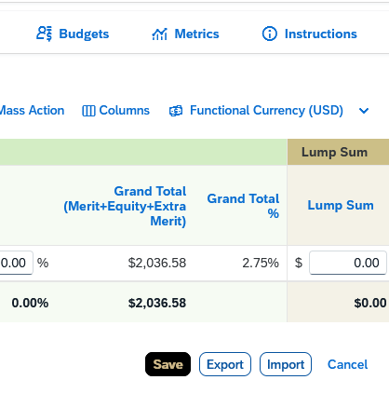
If you plan to make changes in the spreadsheet and import them, mark the checkbox at the top of the pop-up screen. Choose Export as Excel.

If this box is not checked, the file will not be importable.
At the point of import, all columns that were exported must be present, but the order of the columns is not of consequence.

Click Export
Open the exported file.

Save the worksheet on your computer in a location that you will remember.

The exported file contains the same column headers as seen in SuccessFactors.

The columns that can be edited and imported are highlighted in yellow.
If you plan to export the worksheet, make changes, and import the changes, please review the Importing Merit Increase Data QRG prior to exporting the worksheet in order to understand all of the implications and cautions.

Post-Merit Planning Reports
This section outlines the reporting and exporting functionalities available to Executive Reviewers during and following the Merit Planning process.
Additionally, Executive Reviewers – DFA are tasked with gathering final approval from executives/leaders following all entries by Compensation Managers and approvals by One-Up Compensation Managers. The report options below can assist with that task.

Export Worksheet
Select population as desired (See Example: Filter by Division/Department or Example: Filter by Manager sections of this document as needed). Export the worksheet using the instructions found in the Export Merit Worksheet section of this document.

Create Bell Curve Report
To create the Bell Curve Report for the Division, utilize the Executive Reviewer Report Pack located on the Business Management Merit SharePoint site.

Export Detailed and Rollup Reports
These reports provide the aggregate of total values of all users in the Compensation Manager hierarchy below the individual selected. The reports allow for drill-down to other users and review of specific Compensation worksheets. These reports cannot be edited and imported back into the Compensation module.
From the SuccessFactors home page, execute the transaction Rollup Report | 
Use the Find User tool to locate the highest-level Compensation Manager for which you would like to produce the Detailed and Rollup Report. | 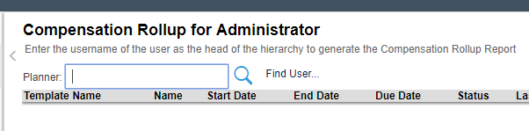
Enter the Compensation Manager’s name and set any other filters as desired.  Click Search Users | 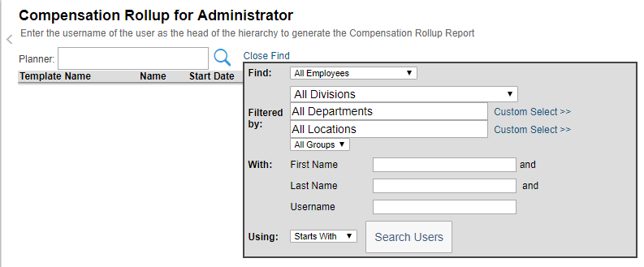
In the Search Results section, click the Compensation Manager’s name. | 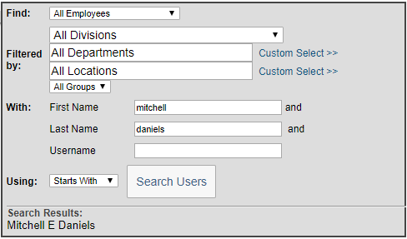
To view the data in the system, click the link found in the Name field.  - See the View in the system section for additional detail  To download the worksheet, click the Action button ()  - See the Download section for additional detail | 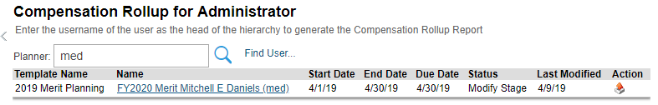

View in the System
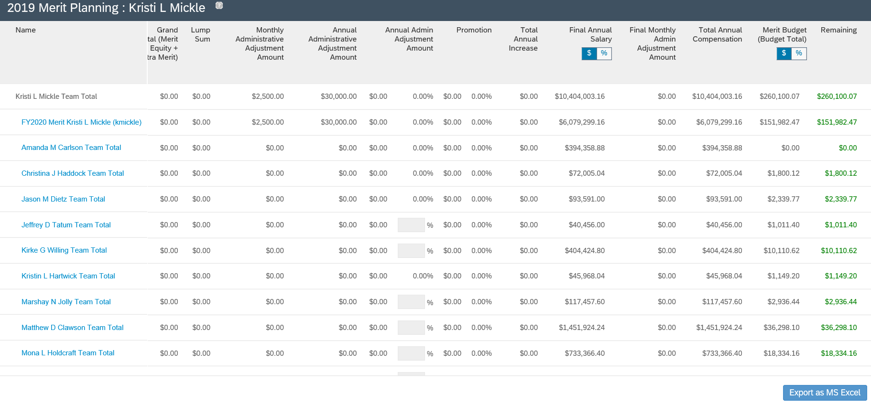
4
3
2
1
The report is displayed. Many of the same columns found on the worksheets are found in this view.
Some helpful features of the report are:
1 | Click each Team Total link to drill in to view the summary view of the worksheets of each of the Compensation Managers below the individual selected.
2 | Option to view the data in $ or %
3 | Columns found on the far right of the worksheet outline the budget utilized and remaining
4 | Option to Export to MS Excel (additional details on this process begin with the next step of this document)

Download
If a message is displayed stating that the report has been scheduled for batch processing, see the Viewing Batch Processed Reports section of this document.  (This typically occurs when attempting to process over 1000 records) | 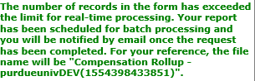
Move or Open and Save the reports in a location you will remember. | 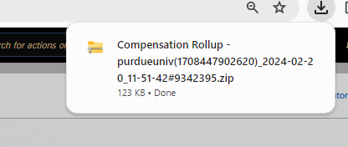  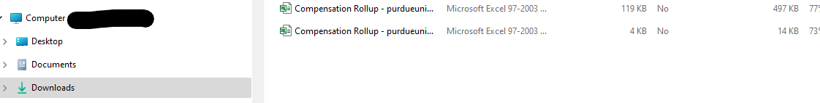
Two reports will appear in the folder:  - Compensation Rollup - Details  - Compensation Rollup - Rollup | 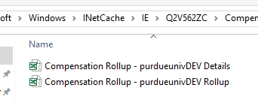
Compensation Rollup – Details displays the expanded view of all worksheets listed and all individuals listed on each worksheet. | 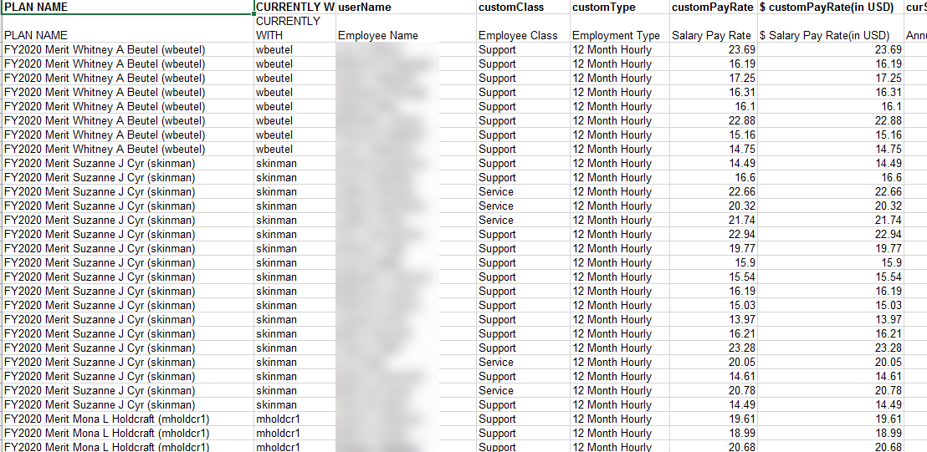
Compensation Rollup – Rollup displays the rollup of each Compensation Manager’s worksheet listed (no individual detail), with budget used, percentage, and budget remaining. | 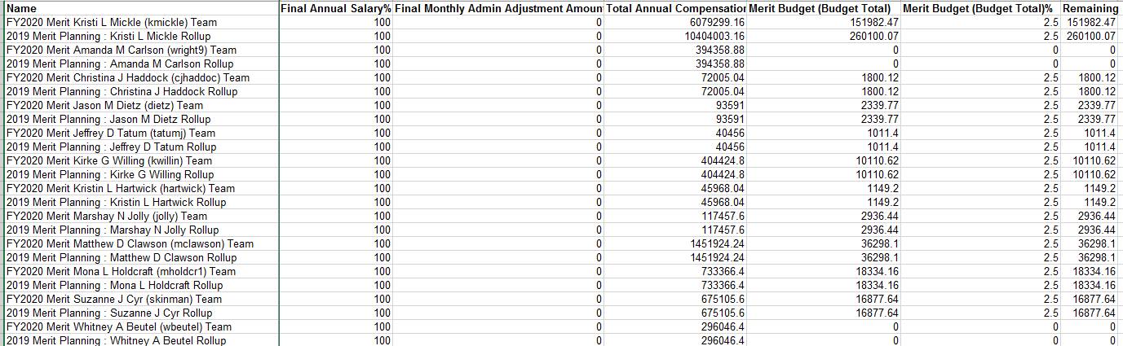

Viewing Batch Processed Reports
If attempting to export a large report, it may be scheduled for batch processing. This section outlines how to retrieve the report.
Use the Home menu to access the Reporting module. | 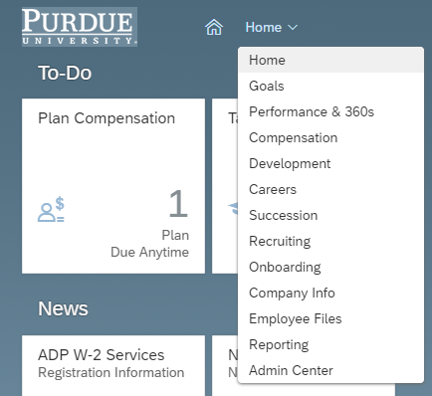
Click View Schedules | 
The report(s) are listed.  Once Status reflects Completed, click on the ellipsis under Action for the desired report and click download.  Choose Download All to download the rollup and details reports. Open or move and save from your Downloads folder to a location you will remember. | 